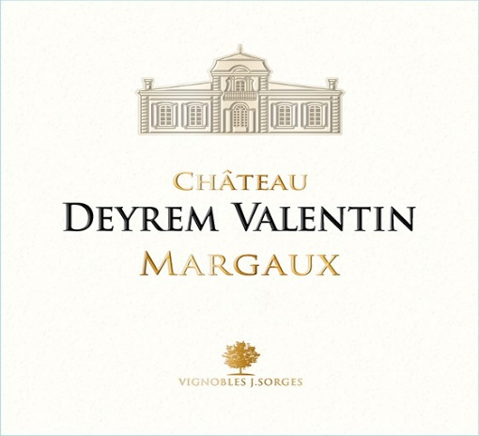

CHATEAU DEYREM VALENTIN 2022
MARGAUX

Exceptional weather conditions, similar to those of vintages of considerable note such as 1900, 1959, 1961 and 1982.

There were a few anxious moments but we escaped the spring frosts.
We all know that summer was hot and dry. However, I had not fully appreciated the extent of the vines’ ability to withstand such conditions. Their root systems were able to find an adequate water supply and the proximity to the Gironde also brought a touch of coolness at night.

We began harvesting the Merlot on 16 September and then, after a week’s break, continued with the Cabernet and Petit Verdot. For as long as the weather was clement, there was no rush so we could allow the grapes to reach optimum maturity.
We decided to use only the Rpulse during alcoholic fermentation. This is a system whereby a pipe is plunged into the base of the vat and air is injected so that the juice rises up to the surface of the marc. Extraction is soft and gentle. By not using a pump at any time during vinification, more delicate, elegant tannins are obtained. This enhances the quality and, because we use much less water and electricity, there are ecological benefits too.

We are delighted with initial tastings of Deyrem Valentin 22 and believe it shows great potential.
The wines are rich, concentrated and powerful, with a definite elegance. “An iron fist in a velvet glove” is how I’d describe them. The nose is extremely complex and aromatic.
On the palate, they are round and full-bodied with very nice length
We believe that Deyrem Valentin 2022 is a very accomplished, well-balanced vintage with a pH of 3.65, a TA of 3.5 and an alcohol content of 14.5% ABV.
BLEND: 56 % CABERENT SAUVIGNON 42 % MERLOT 2 % PETIT VERDOT
Production: 66,000 BOTTLES
The moral of the story? Sunshine is undeniably the best friend of all great vintages.

Area 13 HA

Soils deep gravel dating from the quaternary (Gunz) on the plateau of Marsac overhang the Gironde river temperate climate

Average age of the vine 10 000 vines/HA

Grape variety 50% Merlot 49% Cabernet Sauvignon and 1% Petit Verdot
Viticulture bud pruning, desuckering, manually deleafing and green harvest if necessary. Ploughing, without chemicals.

Harvest only manual with selective sorting. Day to day, observation and tasting the grapes are essential to looking for the optimum maturity.

Vinification in the small concrete tanks, we separate the different grape variety.

Aging 15 months in barrels, 50% new oak, and 50% ONE YEAR USE

Production between 70000 TO 75000 Bottles

