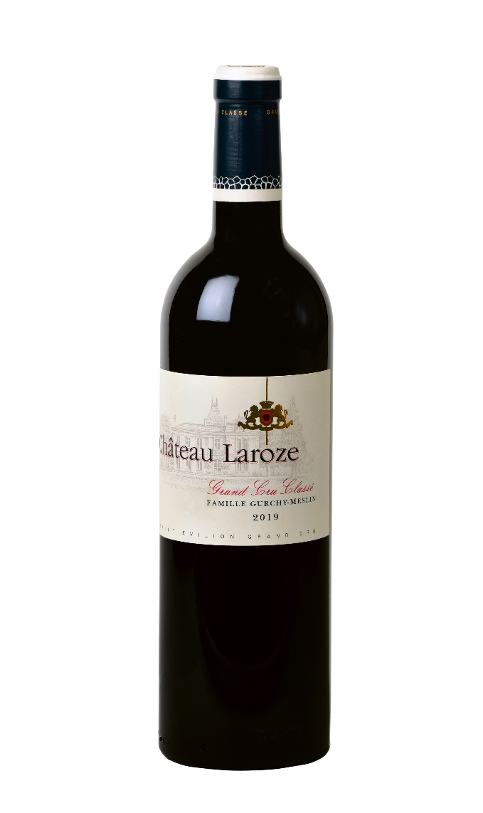 | CHATEAU LAROZE  SAINT-EMILION GRAND CRU CLASSE 2021  OWNER  Family Meslin  Winegrower since 1610 in Saint-Emilion  OENOLOGIST  Jean Philippe FORT/ Hubert de Bouard  VINEYARD  DATE OF CREATION : 1882  AREA : 27 hectares  SOILS : silica on clay  LOCATION : foot of the northwest coast  PLANTING DENSITY : 5600 à 10000 vines/ha  AVERAGE AGE OF THE VINEYARD : 25 years  VINIFICATION  HARVEST: from September 24 to October 8, 2021  TANKS: thermoregulated stainless steel and concrete.  BREEDING: 18 months  BARRELS: 55% new, 35% in vats, 10% amphorae  WINE BLENDING  60 % Merlot  30 % Cabernet franc  10 % Cabernet Sauvignon  CONTACT  1 Goudichau/BP 61  33330 SAINT-EMILIION  info@laroze.com  05 57 24 79 79

